**VEHICLE TRAFFIC MANAGEMENT SYSTEM**

**Vehicle Traffic Management DataBase:**

user(user_id,fname,lname,email,phoneno)

vehicle_info(vehicle_id,user_id,description,plate_number,category_id)

vehicle_category(category_id,categoryname,user_id)

vehicle_owner(vehicle_owner_id,ownername,phone,email,gender,age,vehicle_id)

parking_slot(slot_id,parking_slot_number,parking_slot_status,user_id)

booking(booking_id,slot_id,booking_status,vehicle_id,vehicle_info,booking_duration)

payment(payment_id,booking_id,reference_number,customer_id,amount_paid,amount_due,vehicle_owner_id)

**CREATION OF TABLES:**

1)create table user(user_id int primary key,

fname varchar(20),

lname varchar(20),

email varchar(20),

phoneno int);

2) create table vehicle_info(vehicle_id int primary key,

user_id int,

description varchar(20),

plate_number varchar(20));

3) create table vehicle_category(category_id int primary key,

categoryname varchar(20),

user_id references user(user_id));

*)alter table vehicle_info

add category_id references vehicle_category(category_id) on delete set null ;

4) create table vehicle_owner(vehicle_owner_id int primary key,

ownername varchar(20),

phone varchar(20),

email varchar(20),

gender varchar(20),

age int,

vehicle_id references vehicle_info(vehicle_id));

5) create table parking_slot(slot_id int primary key,

parking_slot_number int,

parking_slot_status int,

user_id references user(user_id));

6)create table booking(booking_id int primary key,

slot_id references parking_slot(slot_id),

booking_status varchar(20),

vehicle_id references vehicle_info(vehicle_id),

booking_duration varchar(20));

7) create table payment(payment_id int primary key,

booking_id references booking(booking_id),

reference_number varchar(20),

customer_id int,

amount_paid int,

amount_due int,

vehicle_owner_id references vehicle_owner(vehicle_owner_id));

**INSERTION OF VALUES INTO TABLES:**

1)insert into user values(1,'adya','palled','adya@gmail.com',9845612345);

insert into user values(2,'anagha','ravi','ravi@gmail.com',8765901237);

insert into user values(3,'abhay','scott','abhay@gmail.com',5638282726);

insert into user values(4,'yuva','raj','raj@gmail.com',1234567890);

insert into user values(5,'sana','sri','sana@gmail.com',9876543210);

2) insert into vehicle_info(vehicle_id,user_id,description,plate_number)values(11,1,'4_wheels','KA316');

insert into vehicle_info(vehicle_id,user_id,description,plate_number)values(12,2,'2_wheels','BLR456');

insert into vehicle_info(vehicle_id,user_id,description,plate_number)values(13,3,'6_wheels','GUR678');

insert into vehicle_info(vehicle_id,user_id,description,plate_number)values(14,4,'8_wheels','MLR345');

insert into vehicle_info(vehicle_id,user_id,description,plate_number)values(15,5,'3_wheels','MAN123');

3) insert into vehicle_category values(101,'car',1);

insert into vehicle_category values(102,'bike',2);

insert into vehicle_category values(103,'truck',3);

insert into vehicle_category values(104,'bus',4);

insert into vehicle_category values(105,'auto',5);

update vehicle_info set category_id=101 where vehicle_id=11;

update vehicle_info set category_id=102 where vehicle_id=12;

update vehicle_info set category_id=103 where vehicle_id=13;

update vehicle_info set category_id=104 where vehicle_id=14;

update vehicle_info set category_id=105 where vehicle_id=15;

4) insert into vehicle_owner values(1,'adya',1234567890,'adya@gmail.com','f',12,11);

insert into vehicle_owner values(2,'anagha',9876543210,'anagha@gmail.com','f',23,12);

insert into vehicle_owner values(3,'abhay',6543218907,'abhay@gmail.com','m',32,13);

insert into vehicle_owner values(4,'yuva',3214569807,'yuva@gmail.com','m',18,14);

insert into vehicle_owner values(5,'sana','1987652397','sana@gmail.com','f',38,15);

5)insert into parking_slot values(21,2,0,1);

insert into parking_slot values(22,3,1,1);

insert into parking_slot values(23,4,0,2);

insert into parking_slot values(24,5,2,4);

insert into parking_slot values(25,6,1,2);

6)insert into booking values(31,21,'0_processing',11,'1_hour');

insert into booking values(32,22,'1_approved',12,'2_hour');

insert into booking values(33,23,'2_cancelled',13,'3_hour');

insert into booking values(34,24,'3_rejected',14,'1_hour');

insert into booking values(35,25,'1_approved',11,'1_hour');

7)insert into payment values(501,31,'a11',01,500,'100',1);

insert into payment values(502,32,'a22',02,400,200,2);

insert into payment values(503,33,'a33',03,200,400,3);

insert into payment values(504,34,'a44',04,300,300,4);

insert into payment values(505,35,'a55',05,500,400,5);

**TABLES WITH TUPLE VALUES**

1. **select * from user;**

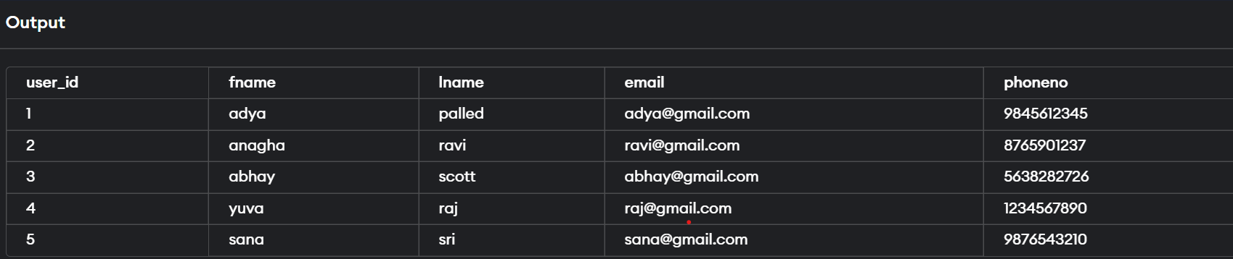

2)**select * from vehicle_info;**

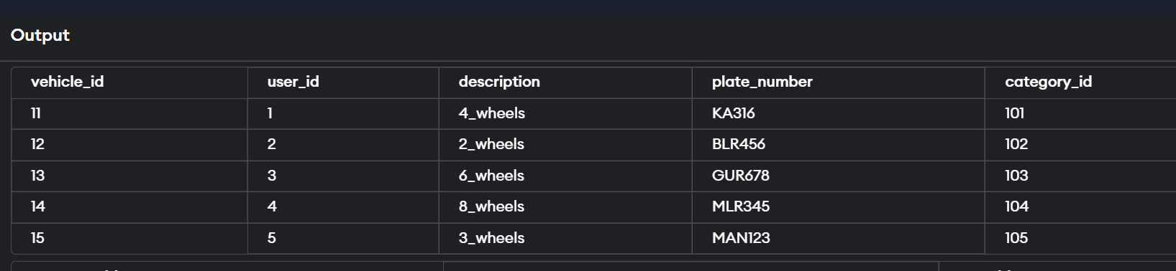

3)**select * from vehicle_category;**

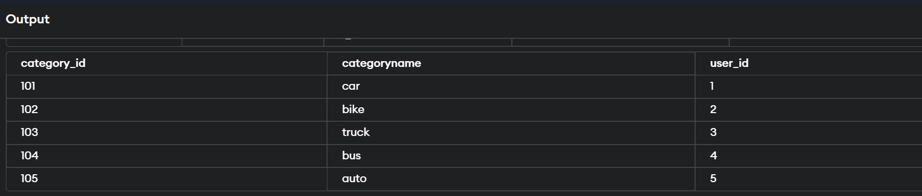

4)select * from vehicle_owner;

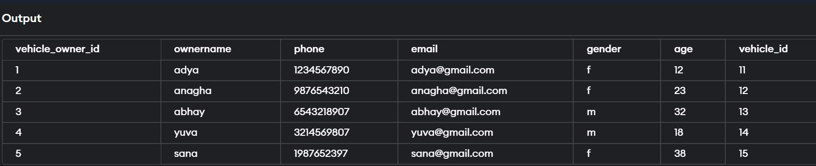

5)**select * from parking_slot;**

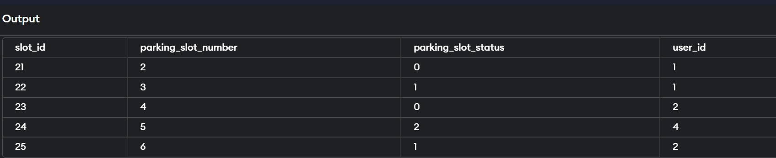

6)**select * from booking;**

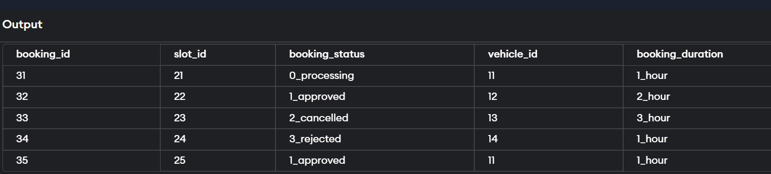

7) **select * from payment;**

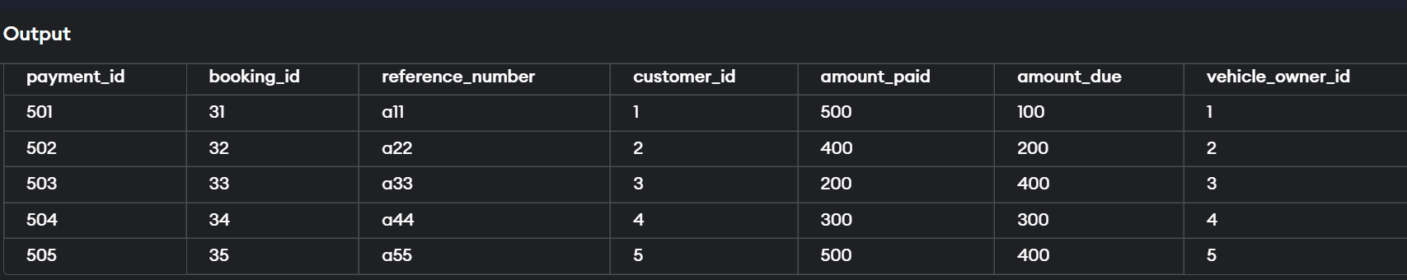

**QUERIES:**

1)**Retrieve the vehicle owner name,vehicle id,payment information who has the payment due.**

select distinct vo.ownername,vo.vehicle_id,p.amount_due,p.amount_paid

from vehicle_owner vo,payment p,vehicle_info vi

where vo.vehicle_owner_id=p.vehicle_owner_id

and vo.vehicle_id=vi.vehicle_id

and p.amount_due is not null;

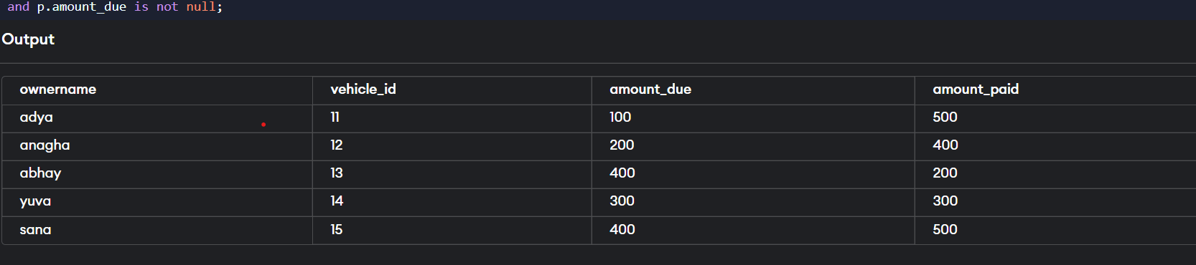

2)**Retrieve the information of vehicles which has three wheels**

select vi.vehicle_id,vi.category_id,vi.plate_number,vc.categoryname

from vehicle_info vi,vehicle_category vc

where vc.category_id=vi.category_id

and vc.category_id=103;

**output:**



3)**Retrieve the owner name of the vehicles whose vehicle owner age is greater than 28**

select ownername from vehicle_owner

where(select count(*)

from vehicle_owner

where age>28

group by age);

**output:**

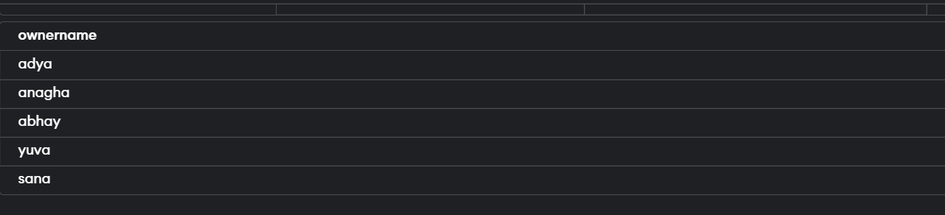

4)**Delete details from vehicle_category table where category_id=104**

delete from vehicle_category

where category_id=104;

select * from vehicle_category;

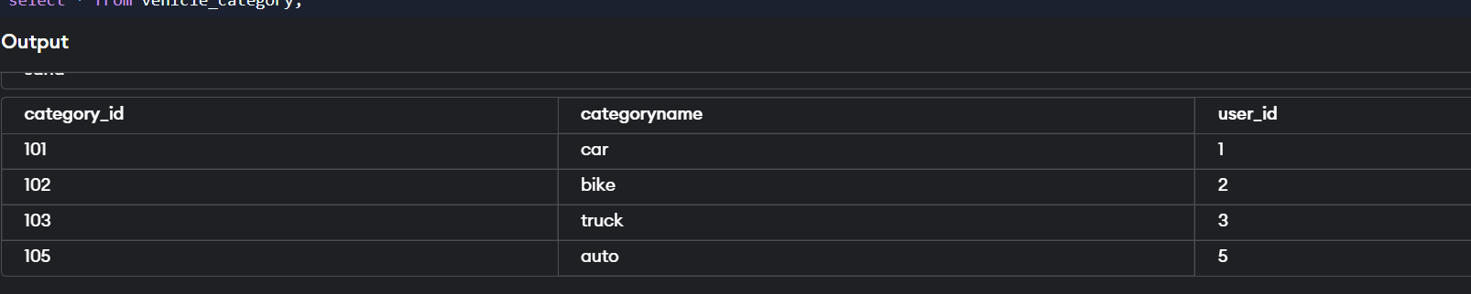

5)**Create view by using tables user,vehicle_owner,vehicle_info.**

create view info as

select u.user_id,u.fname,u.lname,vi.vehicle_id,vi.plate_number

from user u,vehicle_owner vo,vehicle_info vi

where u.user_id=vi.user_id

and vi.vehicle_id=vo.vehicle_id;

select * from info;

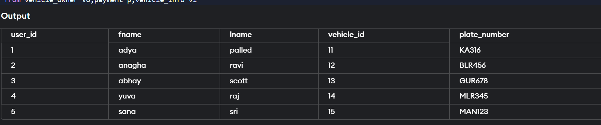

6)**Create Assertion if there are no slots available for parking.**

create assertion slot

CHECK(select * from parking_slot where parking_slot_status=1 or parking_slot_status=2);

Select * from slot;

